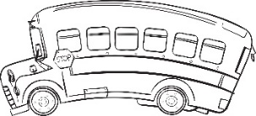
A note from the teacher…
- Book Report OUTLINE - DUE November 14th
  - Student needs to turn in two things:
    - 1. The signed Pre-Approval
    - 2. The OUTLINE
- November Poem DUE—November 30th
- Turkey Trot! We hope to see you at the Annual Turkey Trot on Tuesday, November 21st!

FOCUS PHONOGRAMS:
t w y c x u o ey ee gu oe er ough th ou ar oi ph ed ci ei gn eigh ui ew oy au or ai ea
Assessments
Tuesday:
Reading Comprehension: The Oak and the Reeds

Wednesday:
Written Phonograms: 30 Math Fact Test:
Sums of 12 & Review Facts

Thursday:
Spelling Pre-Test:
List 37-38-39
Reading Comprehension: The Goose that Laid the Golden Eggs

Friday:
Spelling Test &
Sentence Dictation:
List 37-38-39

Language
We are moving into forming compound sentences. Please do a review with your child and make sure they understand the four simple sentence types.
4 Simple Sentence Types:
Declarative (Tells you about something)
Interrogative (asks something)
Exclamatory (a statement said with strong emotion or feeling)
Imperative (a command)
It is crucial that students have this solid foundation before we move on to more in depth writing.

Reading
Stories this week:
Monday:
The Oak and the Reeds
Wednesday:
The Goose that Laid the Golden Eggs

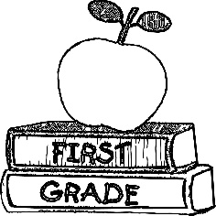

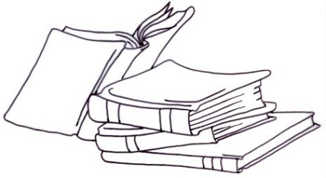
Contact Me
Mrs. Shawnee Baca
sbaca@valleyacademy.com
(623)516-7747 x237
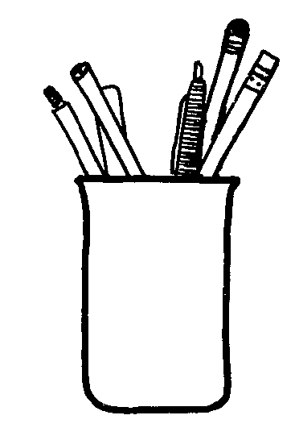
Math
- Lesson 51- Counting Dimes, Nickels, and Pennies
- Lesson 52-Identifying a line of Symmetry/Creating a Symmetrical Design
- Lesson 53-Adding Two-Digit Numbers Using Dimes and Pennies (Part 1)
- Lesson 54- Adding Two-Digit Numbers Using Dimes and Pennies (Part 2)

Social Studies: Thanksgiving
This week students will learn and discuss the meaning of Thanksgiving Day. We will enjoy reading a variety of Thanksgiving books and discussing the things we are most thankful for.

Specials:
Monday: Day 5
Library
Tuesday: Day 6
Art
Wednesday: Day 1
Music
Thursday: Day 2
P.E.
Friday: Day 3
Music

Calendar:
November 15th | Quarter 2 Progress Reports
November 21st | Turkey Trot (details to come…)
November 22nd-24th | NO SCHOOL- Thanksgiving Break
November 30th | Poem Due

